ORACLE B2B 11g

1. TABLE OF CONTENTS

1 B2B introduction 3

1.1 Basic Concepts of B2B 3

1.1.1 What is a B2B? 3

1.1.2 Oracle B2B 11g: Features 3

1.1.3 B2B Building Blocks: Overview 3

1.1.4 Electronic Data Interchange (EDI) 5

1.1.5 Creating Trading Partner Profiles in the Oracle B2B Interface 5

1.1.6 Creating New Users in the Identity Store 6

1.1.7 Adding Users in the Oracle B2B Interface 7

1.1.8 Creating Document Definitions 7

1.1.8.1 Introduction to Document Protocols 8

1.1.8.2 The Document Hierarchy 9

1.1.8.3 Document Protocols with Acknowledgments 10

# B2B introduction

**Business-to-Business (B2B)** involves an enterprise that extends its business processes over the Internet to enable commerce with its trading partners.

### Basic Concepts of B2B

#### What is a B2B?

Oracle B2B enables secure and reliable exchange of messages between an enterprise and its trading partners, enabling:

* Document management
* Transport and exchange management
* Trading partner management
* Reports and monitoring
* System management

#### Oracle B2B 11g: Features

* Tight Integration with the SOA Suite
* Intuitive B2B user interface
* Resubmission of message at the user interface level
* Simplified metadata
* Auto creation of agreement
* Trading partner cloning
* Keystore caching
* Multithreaded message processing engine
* Metrics

#### B2B Building Blocks: Overview

The two major B2B building blocks are:

* Design process
* Infrastructure

**B2B Building Blocks: Design Process**

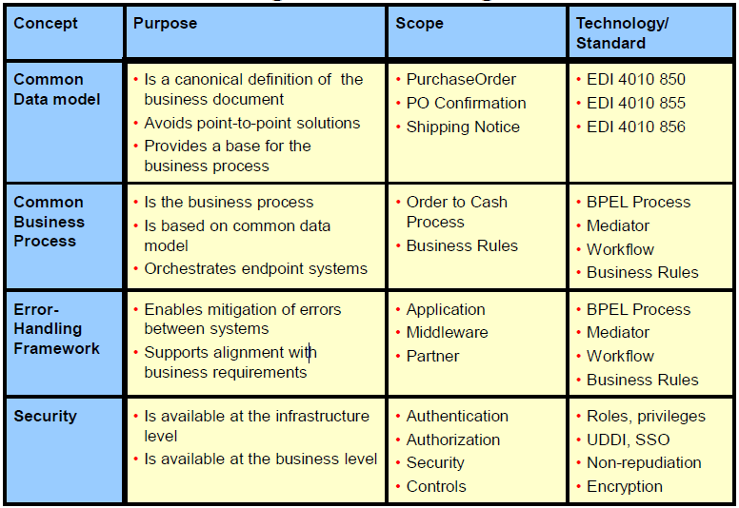

**B2B Building Blocks: Infrastructure**

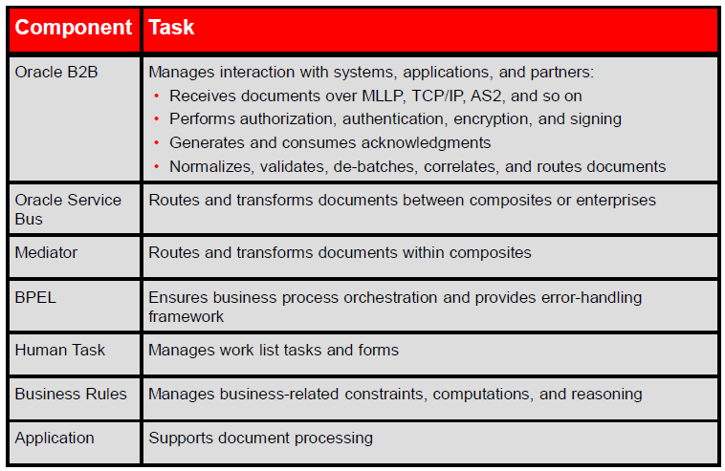

#### Electronic Data Interchange (EDI)

* Electronic Data Interchange (EDI) is a structured B2B document standard that can be electronically exchanged between enterprises and within the enterprise.
* The two main EDI standards are:
  + ASC X12 (Accredited Standards Committee) – North America
  + UN/EDIFACT (United Nations Electronic Data Interchange For Administration, Commerce, and Transport) – Other parts of the world
* Data exchanged between trading partners is organized into transaction sets.

#### Document Definitions

The second step in the Oracle B2B process flow, shown in [Figure](https://docs.oracle.com/cd/E15523_01/user.1111/e10229/bb_doc_flow.htm#BABDHFAD), is to create document definitions.

Figure 4-1 Oracle B2B Process Flow

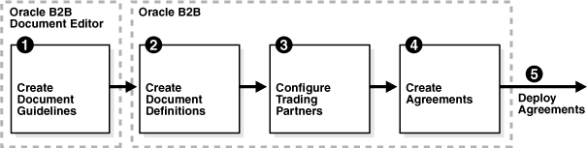  
[Description of "Figure: Oracle B2B Process Flow"](https://docs.oracle.com/cd/E15523_01/user.1111/e10229/img_text/xbbug036.htm)

A document definition specifies the document protocol—the document protocol version and document type—that is used to validate the message. The document definition can be an ECS file, in the case of EDI and HL7 messages, or an XSD/DTD, in the case of XML messages.

The same document definition is used by both the host and remote trading partner in a transaction. It must adhere to the standards for document protocols, protocol versions, and document types. This is straightfoward when you use Oracle B2B Document Editor to create the document guideline files (Step 1 in [Figure](https://docs.oracle.com/cd/E15523_01/user.1111/e10229/bb_doc_flow.htm#BABDHFAD)) and then the Oracle B2B interface to import those files when creating the document definition (Step 2 in [Figure](https://docs.oracle.com/cd/E15523_01/user.1111/e10229/bb_doc_flow.htm#BABDHFAD)).

#### Introduction to Document Protocols

Figure shows the document protocols supported in Oracle B2B. Using the Custom protocol and the many guideline documents in Oracle B2B Document Editor, you can define most protocols. When you add a new document protocol, it is always a Custom document.

***Figure 4-2 Oracle B2B Document Protocols***

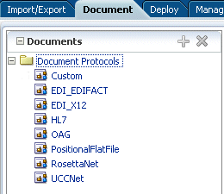  
[Description of "Figure : Oracle B2B Document Protocols"](https://docs.oracle.com/cd/E15523_01/user.1111/e10229/img_text/bb_docprot.htm)

As part of the document definition, you provide the document guideline files, which are typically created in Oracle B2B Document Editor. (For Custom documents, you cannot use Oracle B2B Document Editor.) If validation is enabled, then, at run time, the payload must conform to the document definition file type you use.

#### The Document Hierarchy

You can think of a document protocol as a hierarchy, as shown in [Figure](https://docs.oracle.com/cd/E15523_01/user.1111/e10229/bb_doc_flow.htm#BABDGAFG).

***Figure: Document Hierarchy***

Document hierarchy  
[Description of "Figure : Document Hierarchy"](https://docs.oracle.com/cd/E15523_01/user.1111/e10229/img_text/bb_xbbug039.htm)

A document protocol can consist of multiple document protocol versions. A document protocol version can consist of multiple document types. A document type can consist of multiple document definitions. Typically, you start with one document definition and customize it for different trading partners.

[Figure](https://docs.oracle.com/cd/E15523_01/user.1111/e10229/bb_doc_flow.htm#BABCHGBB) shows a document protocol hierarchy as it applies to EDI X12.

***Figure 4-4 EDI X12 Document Hierarchy***

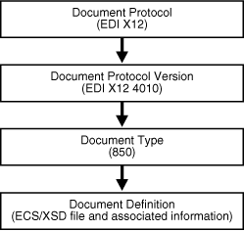  
[Description of "Figure EDI X12 Document Hierarchy"](https://docs.oracle.com/cd/E15523_01/user.1111/e10229/img_text/xbbug008.htm)

In the Oracle B2B interface, as you create a document definition, the document protocol hierarchy is reflected in the definition:

*DocumentProtocol—Version—DocumentType—DocumentDefinitionName*

[Example 4-1](https://docs.oracle.com/cd/E15523_01/user.1111/e10229/bb_doc_flow.htm#BABECIHB) shows the hierarchy reflected in the definition for an EDI EDIFACT document.

***Example 4-1 Document Definition Name for an EDI EDIFACT Document***

Document protocol: EDI_EDIFACT

Document protocol version: D98A

Document type: ORDERS

Document definition: ORDERS_def

The resulting document definition is

EDI_EDIFACT-D98A-ORDERS-ORDERS-def

[Example](https://docs.oracle.com/cd/E15523_01/user.1111/e10229/bb_doc_flow.htm#BABJEGFH)  shows examples of document definitions for a Health Care 7 admit/visit notification and an X12 version 4010 purchase order, respectively.

***Example 4-2 Document Definition Names for HL7 and X12 Documents***

HL7-2.3.1-ACK_A01-ACK_A01_Doc_Def

EDI_X12-4010-850-850def

#### Document Protocols with Acknowledgments

For any message flow that involves an acknowledgment, Oracle B2B sends an acknowledgment only once. Resubmission does not generate another acknowledgment if the message has already been acknowledged. If further information about the message state is needed, then the trading partner must be notified by some other means (for example, e-mail).

# B2B TASKS

### Basic Setup of B2B

#### Creating Trading Partner Profiles in the Oracle B2B Interface

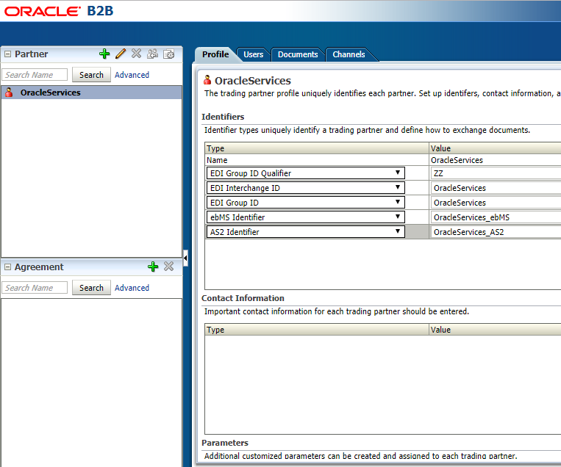

#### Creating New Users in the Identity Store

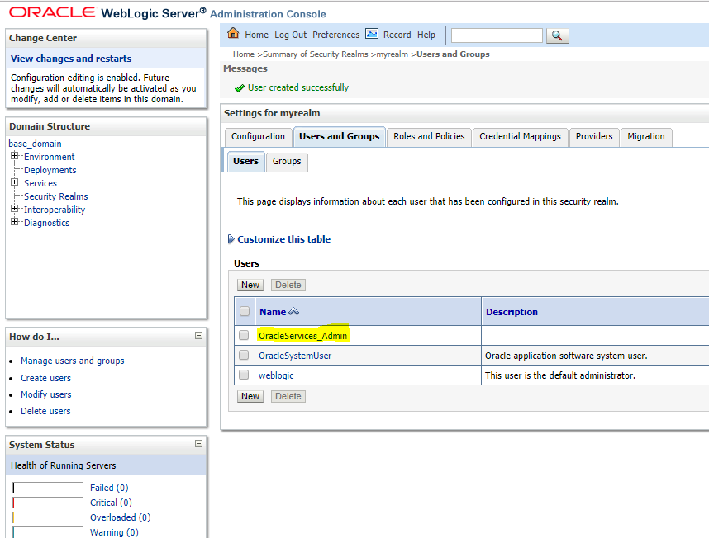

#### Adding Users in the Oracle B2B Interface

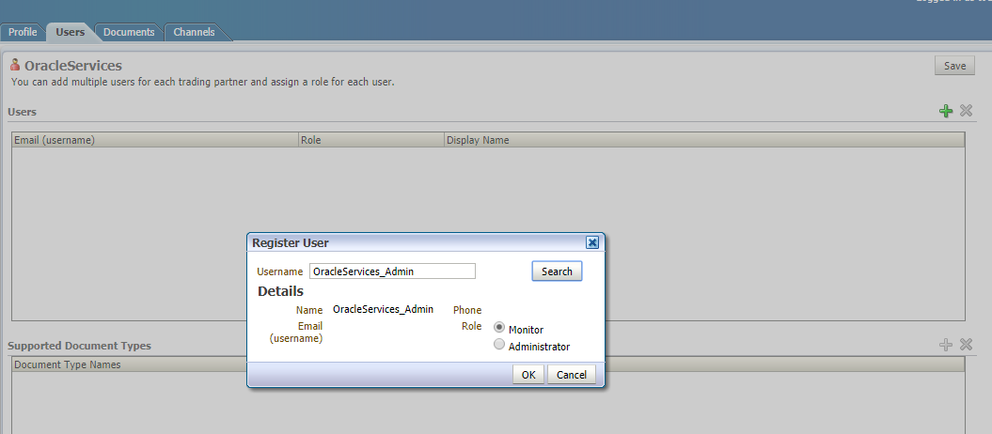

#### Creating document definition for Custom

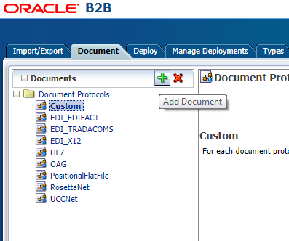

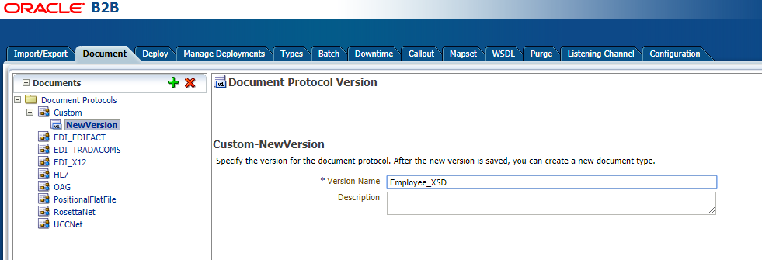

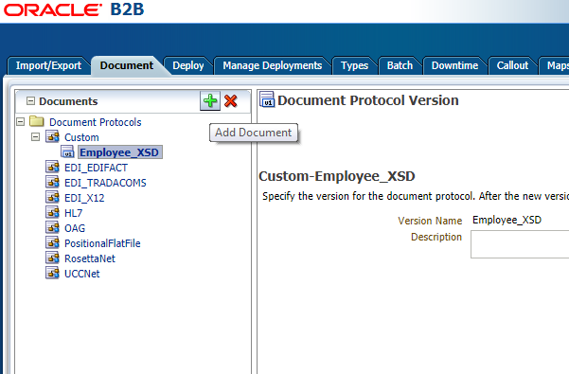

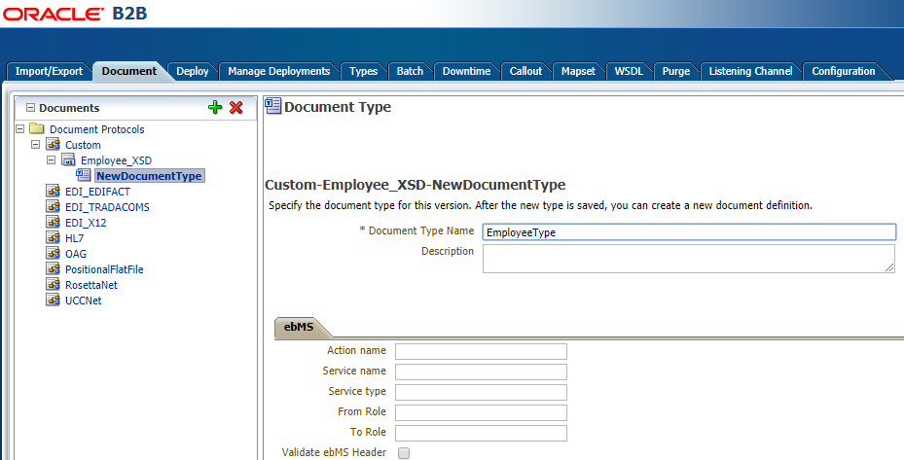

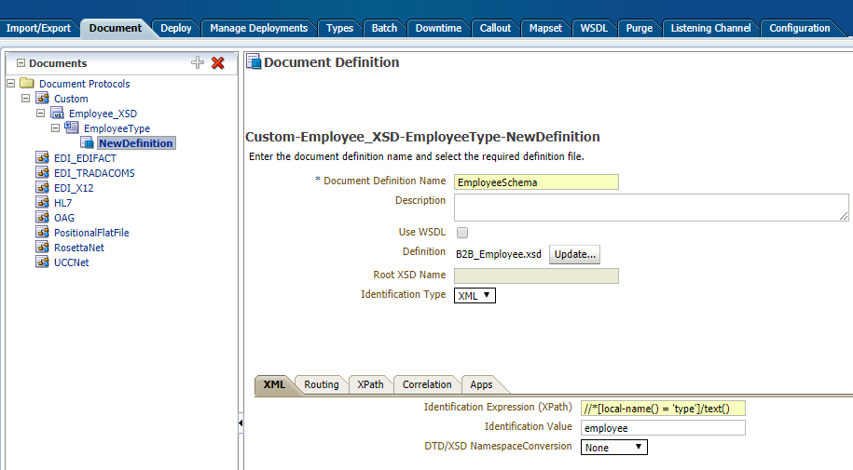

#### Creating JMS Channel

